Towards Artificial Ossification for Bone-inspired Technical Structures

R.Starke & I. Vukorep

*Chair of Digital Design Department, BTU Cottbus-Senftenberg, Germany, starke@b-tu.de, ilija.vukorep@b-tu.de*

K. Frommelt

*DFG Research Training Group 1913, BTU Cottbus-Senftenberg, Germany, konrad.frommelt@b-tu.de*

A. Melcher

*Niessink Engineering GmbH, Germany*

T. Hinze

*Department of Bioinformatics, Friedrich Schiller University Jena, Germany, thomas.hinze@uni-jena.de*

ABSTRACT: Since its first description in 1892, the adaptation of internal bone structure to changing loading conditions over time, known as Wolff's Law (Wolff, 1892), has inspired a wide range of research and imitation. This investigation presents a new bone-inspired algorithm, intended for the structural design of technical structures and capable of optimising the shape and size of three-dimensional lattice structures. Unlike conventional structural optimisation methods, it uses interacting artificial agents that closely follow the cellular behaviour of the biological blueprint. Agents iteratively move, alter cross-sections, and reposition axes in the latticework. The efficacy of the algorithm is tested and evaluated in two case studies. This agent-based approach lays the theoretical foundation for an implementation of adaptive structural building components and provides a tool for further research into the spatial aspects of natural ossification.

1. INTRODUCTION

Ossification is a biological process that constantly remodels the inner bone structure in reaction to the applied loads. Tube bones in mammal skeletons, like femur or humerus, consist of an outer shell, the cortical bone, and a porous inner framework, the trabecular bone. The simulation of this porous framework’s adaptability is at the core of this research. The result is a new lightweight shape and size optimisation algorithm, capable of dynamically visualizing ossification principles, including osteoblast and osteoclast movement.

While the proposed algorithm utilizes the finite element method (FEM), it is not used for the topology optimisation as in the Soft-Kill-Option (SKO) method or a direct optimisation of trabecular architecture (Jang et al., 2008). Instead, a randomly initialized trabecular architecture is calculated with FEM, and the resultant forces are further processed as stimuli for artificial osteoblasts and osteoclasts (Melcher et al., 2019). This adheres much closer to natural ossification than conventional structural optimisation solutions.

1. METHOD

In natural ossification the remodelling through cells, named osteoblasts and osteoclasts, leads to two effects: an increase or decrease of cross-sectional area, and the gradual shift of the filament axis when material is added or removed asymmetrically to the cross-section, effectively changing the structural geometry. The slow lateral shift of the filaments can be imagined roughly like the formation of dripstone. In the Algorithm, this process is simplified and repeated for a defined number of steps by artificial agents. Each Iteration is made up of the following subsequent steps: The structural calculation of internal forces, the repositioning of agents, the alteration of the beam diameter, and the repositioning of beam axes.

1. RESULTS

The average comparison stress was reduced from 0.841 kN/cm² in the benchmark structure with uniform radii to 0.098 kN/cm² in the optimised structure (Figure 1). This is achieved by the repositioning of beam axes, which leads to orientations approaching an ideal line of thrust and the adoption of cross-section radii according to the local equivalent stress. In the three-dimensional model, the resulting beam geometry resembles a bowstring arch bridge.

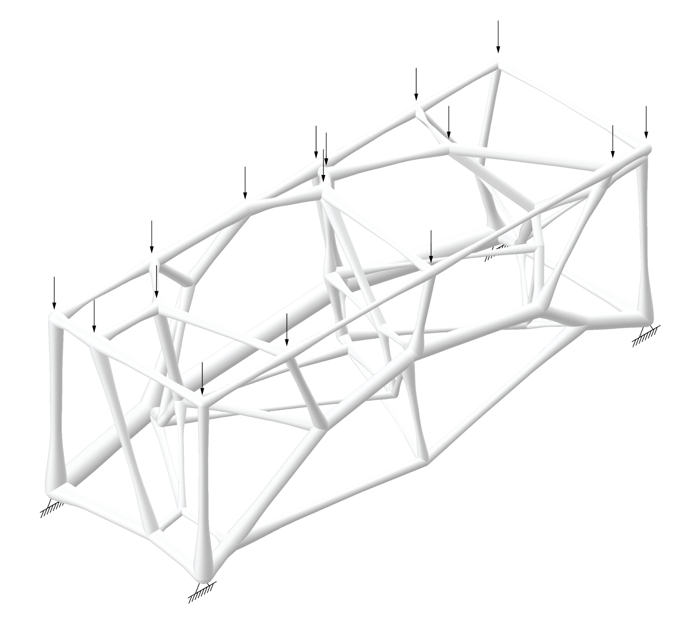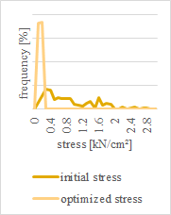

Figure 1. a: optimised model with visible arch structure. b: Distribution of stress within the model

1. CONCLUSION

While the algorithm proves to be capable of shape and size optimisation (Figure 1), the agent-based approach comes with several drawbacks. The artificial agents' limited vision, limited movement, and limited effect pose an additional processing layer and make it inferior to conventional structural optimisation methods, where the size and shape of the elements are the results of a direct calculation. Nonetheless, natural ossification cannot be described in a single optimal state but only as a process of successive actions of multiple agents influencing one another. This becomes evident by changing the starting point of a single agent, which has a non-linear impact and completely changes the structural outcome, resulting in a different local optimum.

The initialization parameters of the algorithm could provide an interesting vantage point for research into the spatial conditions for bone homeostasis and the agent-based system can serve as a theoretical basis for the realization of adaptable load-bearing building structures. While the technology for its execution might not exist, the case of application does. The Python source code of the algorithm is publicly available at: https://github.com/rolfstarke/artificial-ossification

REFERENCES

Jang, I.G., Kim, I.Y., 2008. Computational study of Wolff’s law with trabecular architecture in the human proximal femur using topology optimization. Journal of Biomechanics 41, 2353–2361.

Melcher, A., Vukorep, I., Hinze, T., 2019. Construction of Stable and Lightweight Technical Structures Inspired by Ossification of Bones Using Osteogenetic P Systems, in: Hinze, T., Rozenberg, G., Salomaa, A., Zandron, C. (Eds.), Membrane Computing. SpringerSeries Lecture Notes in Computer Science Vol. 11399, pp. 208–228.

Wolff, 1892. Das Gesetz der Transformation der Knochen. Hirchwild, Berlin (Translated as The Law of Bone Remodeling. Springer, Berlin).

Video Abstract: <https://www.b-tu.de/owncloud/s/rZBWdMtWGbNLRcF>

Password: ICSA2022